

Name: Aashish Bansal

Registration No.: 19BIT0346

Course Code: ITE1002

Course Name: Web Technologies

Faculty Name: Prof. Mareeshwari V

Theory Slot: G1

Lab Slot: L59 + L60

Table of Contents

Question 1: Introduction to HTML 2

Part a 2

HTML Code 2

Code URL 2

Code Screenshot 2

Output Screenshot 2

Part b 3

HTML Code 3

Code Screenshot 4

Code URL 4

Output Screenshot 4

Part c 4

HTML Code 4

Code Screenshot 5

Code URL 5

Output Screenshot 5

Part d 5

HTML Code 5

Code Screenshot 6

Code URL 7

Output Screenshot 7

Part e 7

HTML Code 7

Code Screenshot 8

Code URL 8

Output Screenshot 8

Part f 8

HTML Code 8

Code Screenshot 9

Code URL 9

Output Screenshot 9

Question 2 9

Assessment 1

# Question 1: Introduction to HTML

## Part a

Question: Create a webpage that prints your name to the screen.

### HTML Code

<!DOCTYPE html>

<html>

<head>

<title></title>

</head>

<body>

<h1>Aashish Bansal</h1>

<h2>19BIT0346</h2>

</body>

</html>

### Code URL

file:///C:/Aashish/VIT/Semester%203/ITE1002%20PC%20Web%20Technologies%20Laboratory/Assessment%201/19BIT0346%201a.html

### Code Screenshot

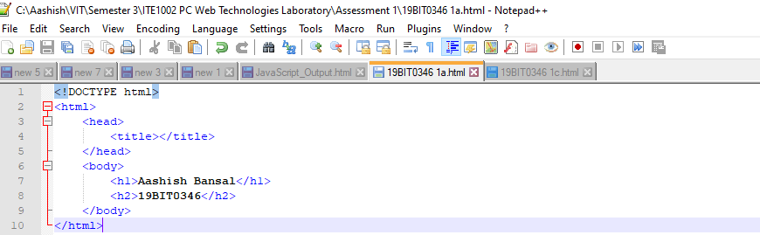

### Output Screenshot

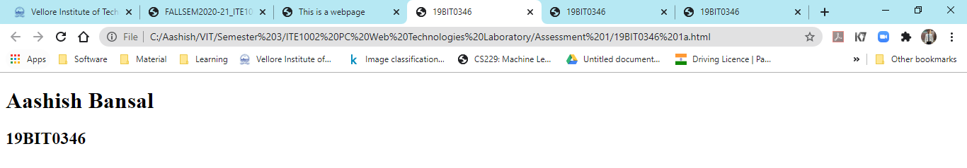

## Part b

Question: Create a webpage that prints the numbers 1 - 10 to the screen.

### HTML Code

<!DOCTYPE html>

<html>

<head>

<title></title>

</head>

<body>

<h1>Aashish Bansal</h1>

<h2>19BIT0346</h2>

<h4>Create a webpage that prints the numbers 1 - 10 to the screen.</h4>

<p>

1<br>

2<br>

3<br>

4<br>

5<br>

6<br>

7<br>

8<br>

9<br>

10<br>

</p>

</body>

</html>

### Code Screenshot

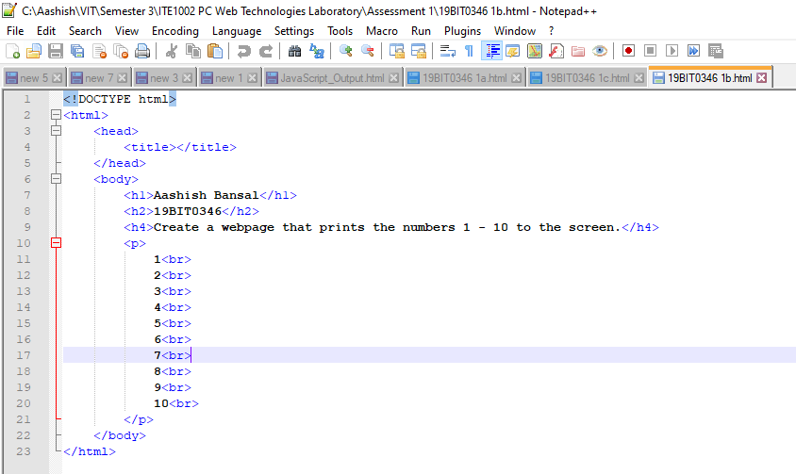

### Code URL

file:///C:/Aashish/VIT/Semester%203/ITE1002%20PC%20Web%20Technologies%20Laboratory/Assessment%201/19BIT0346%201b.html

### Output Screenshot

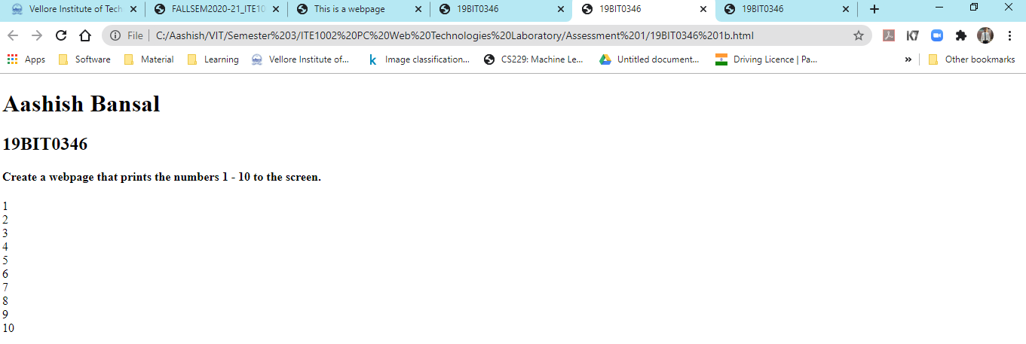

## Part c

Question: Create a webpage and set its title to "This is a webpage".

### HTML Code

<!DOCTYPE html>

<html>

<head>

<title>This is a webpage</title>

</head>

<body>

<h1>Aashish Bansal</h1>

<h2>19BIT0346</h2>

<h4>Create a webpage and set its title to "This is a webpage".</h4>

</body>

</html>

### Code Screenshot

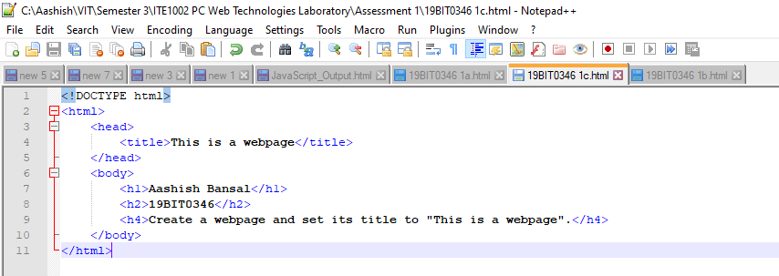

### Code URL

file:///C:/Aashish/VIT/Semester%203/ITE1002%20PC%20Web%20Technologies%20Laboratory/Assessment%201/19BIT0346%201c.html

### Output Screenshot

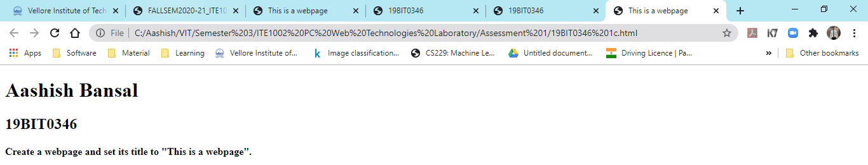

## Part d

Question: Create a webpage that prints the message "When was this webpage created? Check page's title for the answer." to the screen, and set the title of the page to the current date.

### HTML Code

<!DOCTYPE html>

<html>

<head>

<title>

<script>

document.getElementById("date").innerHTML = Date();

</script>

</title>

</head>

<body>

<h1>Aashish Bansal</h1>

<h2>19BIT0346</h2>

<h4>Create a webpage that prints the message "When was this webpage created?<br>

Check page's title for the answer." to the screen, and set the title of the page to<br>

the current date.

</h4>

<p>When was this webpage created?</p>

<p id="date"></p>

<script>

document.title=new Date();

document.getElementById("date").innerHTML = Date();

</script>

</body>

</html>

### Code Screenshot

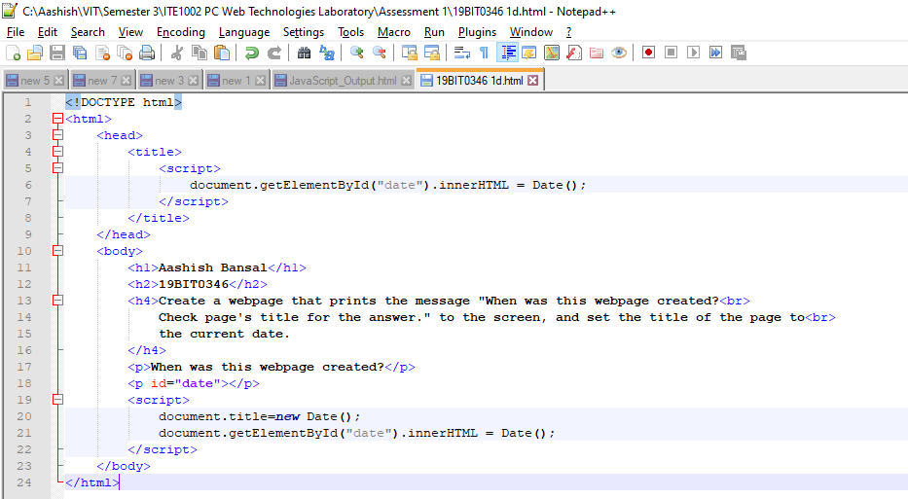

### Code URL

file:///C:/Aashish/VIT/Semester%203/ITE1002%20PC%20Web%20Technologies%20Laboratory/Assessment%201/19BIT0346%201d.html

### Output Screenshot

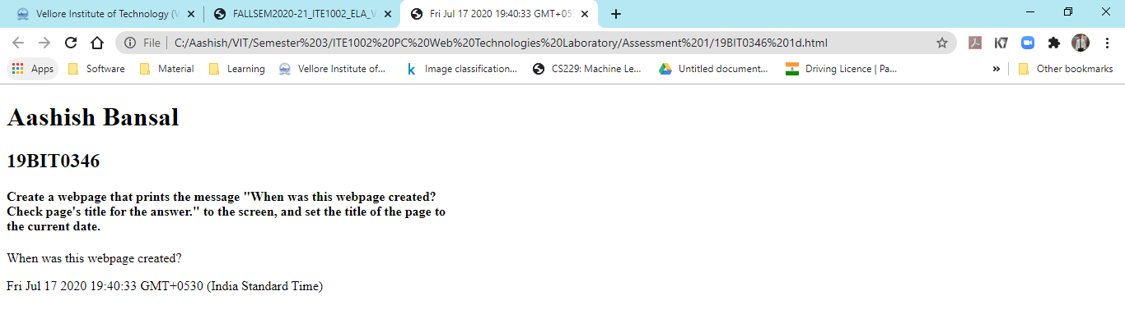

## Part e

Question: Create a webpage that prints any text of your choice to the screen; do not include a head section in the code

### HTML Code

<!DOCTYPE html>

<html>

<body>

<h1>Aashish Bansal</h1>

<h2>19BIT0346</h2>

<h4>

Create a webpage that prints any text of your choice to the screen; do not<br>

include a head section in the code.

</h4>

For this webpage, the file name has been displayed as the name of the file since the<br>

head section is missing.

</body>

</html>

### Code Screenshot

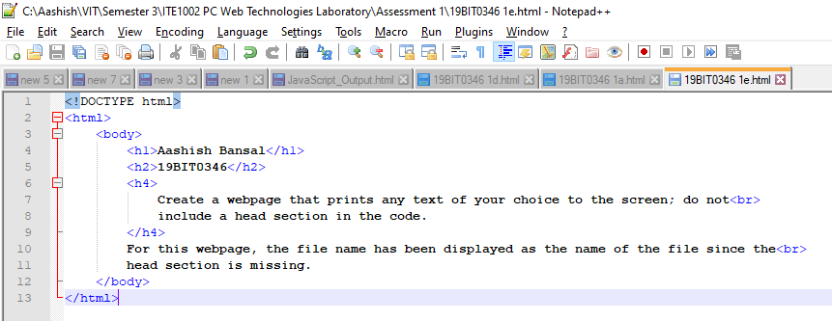

### Code URL

file:///C:/Aashish/VIT/Semester%203/ITE1002%20PC%20Web%20Technologies%20Laboratory/Assessment%201/19BIT0346%201e.html

### Output Screenshot

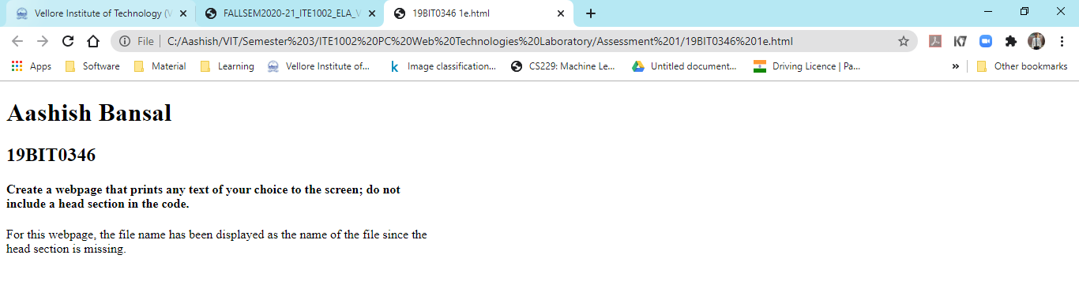

## Part f

Question:

Create a webpage which keeps track of the browsers information and do the following

* refreshes its page in 5 seconds,
* expires in a duration of time

### HTML Code

<!DOCTYPE html>

<html>

<head>

<title>19BIT0346</title>

<meta http-equiv="refresh" content="5; URL=C:\Aashish\VIT\Semester 3\ITE1002 PC Web Technologies Laboratory\Assessment 1\19BIT0346 1f.html">

<meta http-equiv="refresh" content="6000;URL=C:\Aashish\VIT\Semester 3\ITE1002 PC Web Technologies Laboratory\Assessment 1\19BIT0346 1f.html" />

</head>

<body>

<h1>Aashish Bansal</h1>

<h2>19BIT0346</h2>

<h4>

Create a webpage which keeps track of the browsers information and do the following<br>

• refreshes its page in 5 seconds,<br>

• expires in a duration of time

</h4>

</body>

</html>

### Code Screenshot

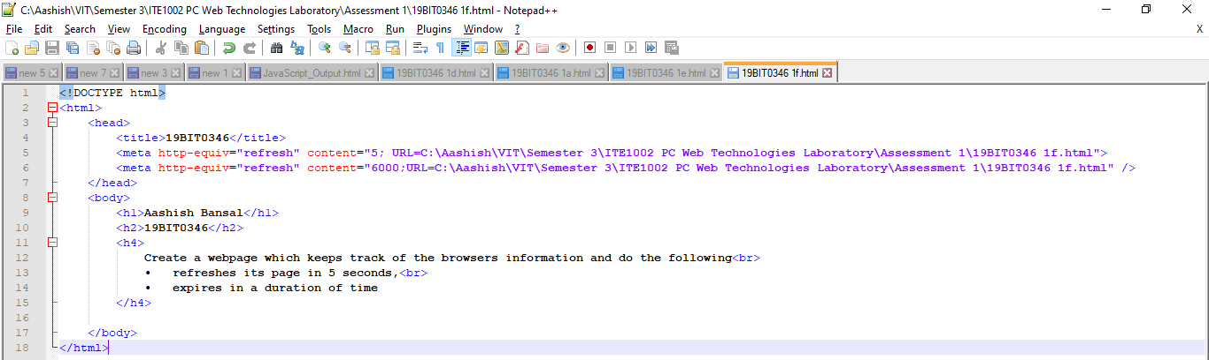

### Code URL

file:///C:/Aashish/VIT/Semester%203/ITE1002%20PC%20Web%20Technologies%20Laboratory/Assessment%201/19BIT0346%201f.html

### Output Screenshot

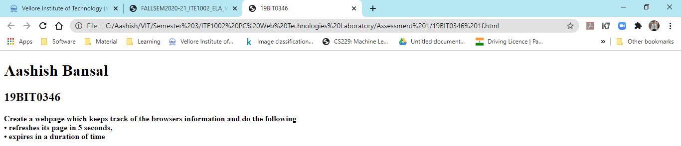

# Question 2: